# ERA5 download

* First port of call is wiki page for downloading data:  
  <https://confluence.ecmwf.int/display/CKB/How+to+download+ERA5>  
  I followed the link at the centre of the screen (underlined)

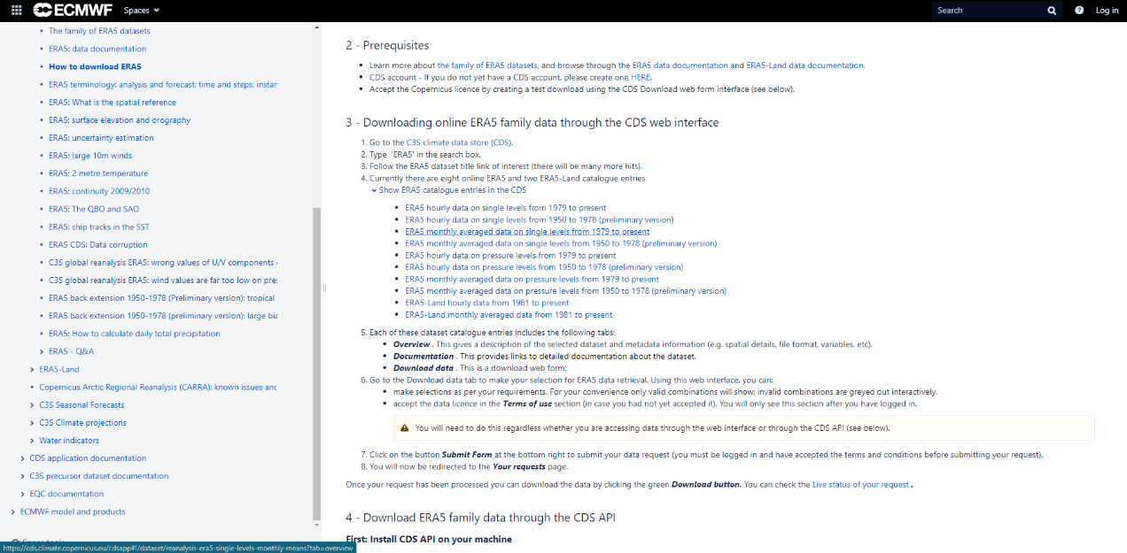

* Webpage for monthly data 1979-present:  
  <https://cds.climate.copernicus.eu/cdsapp#!/dataset/reanalysis-era5-single-levels-monthly-means?tab=overview>

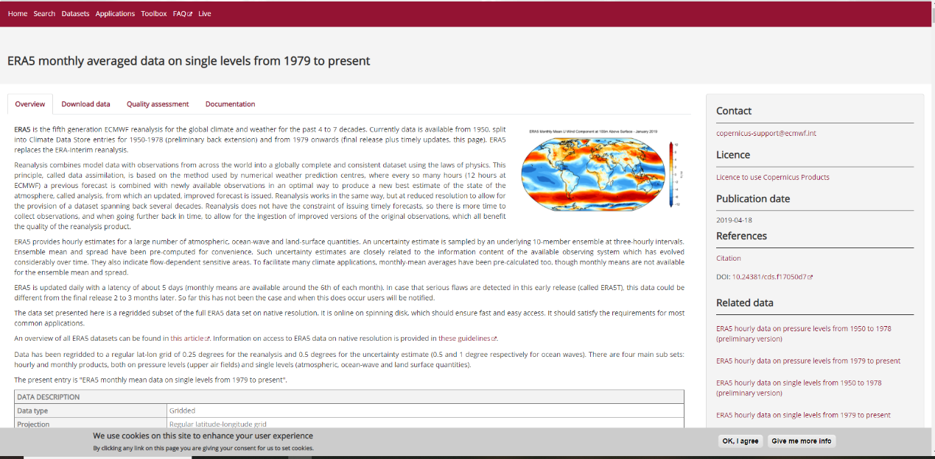

* I select Monthly averages, 2m temp and SST 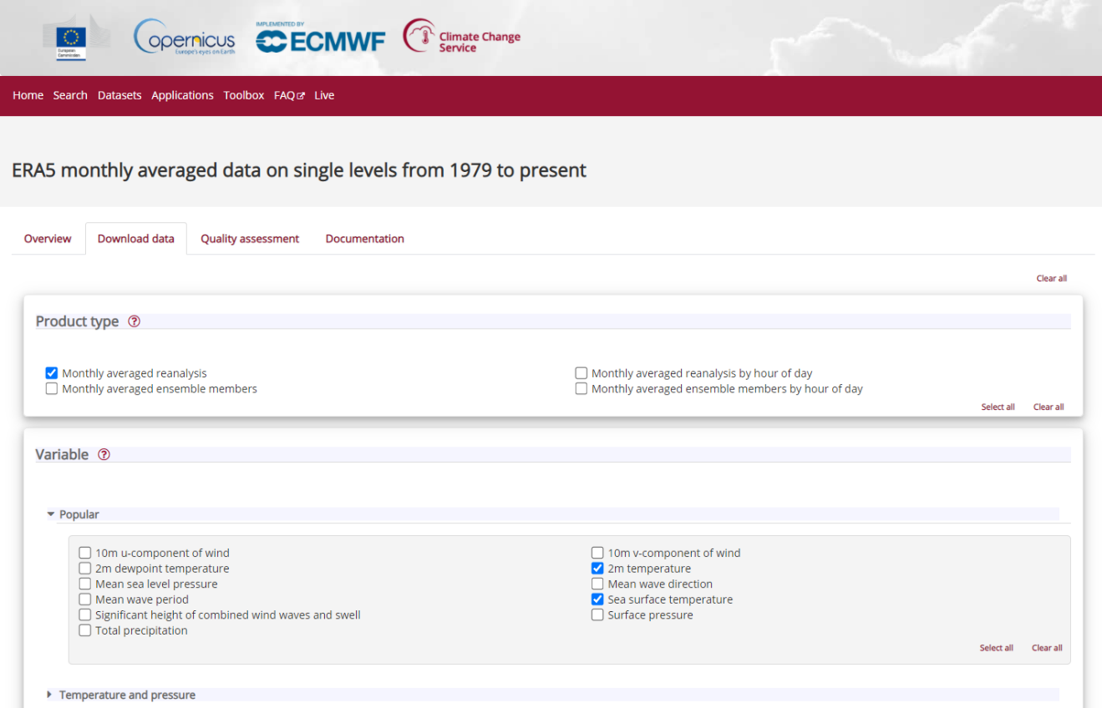  
  I selected All Years, All Months and the WHOLE REGION!  
  I ask for NetCDF even though it says its experimental  
  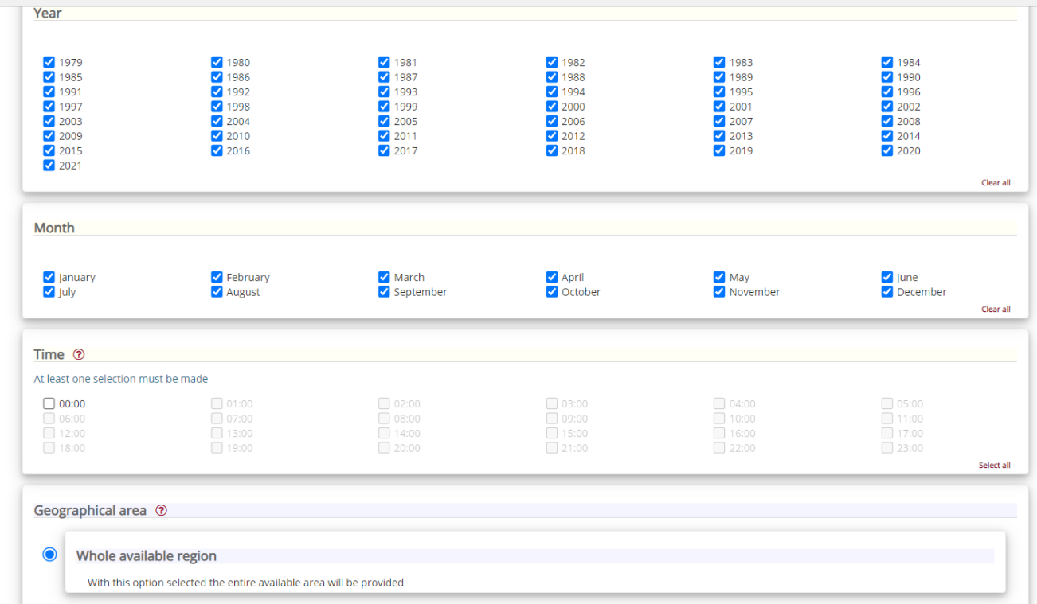

Notes

* The ERA5 HRES (High Resolution) data has a native resolution of 0.28125 degrees (31km), and the EDA (Ensemble) has a resolution of 0.5625 degrees (62km).
* Geographic Coordinate System: WGS84